**WEEK 4**

**(A)AIM:** To write a program to demonstrate packages.

**THEORY:**A java package is a group of similar types of classes, interfaces and sub-packages. Package in java can be categorized in two form, built-in package and user-defined package. There are many built-in packages such as java, lang, awt, javax, swing, net, io, util, sql etc.

**Advantage of Java Package**

1) Java package is used to categorize the classes and interfaces so that they can be easily maintained.

2) Java package provides access protection.

3) Java package removes naming collision.

Send the class file to another directory or drive. There is a scenario, I want to put the class file of A.java source file in classes folder of c: drive.

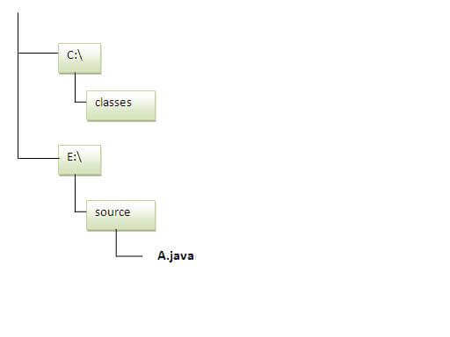

**ALGORITHM:**

STEP1: START

STEP2: Create a package with name ‘mypack’ in the current directory

STEP3: Write a simple java program to print the message “welcome to package” ,import the package ‘mypack’ and save the file with name Simple.java

STEP4: set the class path to send the class file of A.java source file into classes folder of c: drive.

STEP5:STOP

### To Compile:

**e:\sources> javac -d c:\classes Simple.java**

### To Run:

|  |
| --- |
| To run this program from e:\source directory, you need to set classpath of the directory where the class file resides. |
| **e:\sources> set classpath=c:\classes;.;** |
| **e:\sources> java mypack.Simple** |

**SOURCE CODE**

package mypack;

public class Simple{

public static void main(String args[]){

System.out.println("Welcome to package");

}

}

**OUTPUT:**

**Compile time:-** javac –d .Simple.java

**Run time:-** java mypack.Simple

Welcome to package

**(B)AIM:** To write a Java program to create an abstract class

**THEORY:** We can require that some methods be overridden by sub classes by specifying the abstract type modifier. These methods are sometimes referred to as sub classer responsibility as they have no implementation specified in the super class. Thus a sub class must override them. Any class that contains one or more abstract methods must also be declared abstract. Such types of classes are known as abstract classes. Abstract classes can contain both abstract and non-abstract methods.

**ALGORITHM:**

STEP1: START

STEP2: Create an abstract class named Shape.

STEP3: Declare integer variables for height, width and radius in the abstract class Shape.

STEP4: Declare abstract method printArea() in the abstract class Shape.

STEP5: Create sub classes Rectangle, Triangle and Circle that extends Shape.

STEP6: Implement the printArea() method in all three classes.

STEP7: Invoke the methods in the main class by the respective objects.

STEP8: END

**SOURCE CODE:**

abstract class Shape

{

int a=2;

int b=4;

abstract void printArea();

}

class Rectangle extends Shape

{

void printArea()

{

int r=a*b;

System.out.println("Area for Rectangle="+r);

}

}

class Triangle extends Shape

{

void printArea()

{

int t=(a*b)/2;

System.out.println("Area for Triangle="+t);

}

}

class Circle extends Shape

{

void printArea()

{

int area=(int)(3.14*a*a);

System.out.println("Area for Circle with radius "+a+" is= "+area);

}

}

public class AbstractDemo

{

public static void main(String args[])

{

Rectangle r= new Rectangle();

Triangle t= new Triangle();

Circle c=new Circle();

Shape s;

s=r;

s.printArea();

s=t;

s.printArea();

s=c;

s.printArea();

}

}

**OUTPUT:**

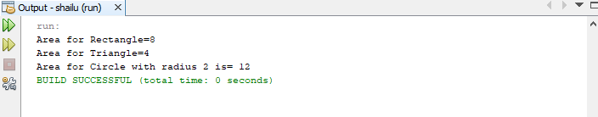

# VIVA - VOCE

1. Define java Inheritance.

Inheritance in Java is a concept that acquires the properties from one class to other classes; for example, the relationship between father and son. Inheritance in Java is a process of acquiring all the behaviours of a parent object.

1. Define java package

A java package is a group of similar types of classes, interfaces and sub packages. Package in java can be categorized in two form, built-in package and user-defined package. There are many built-in packages such as java, lang, awt, javax, swing, net, io, util, sql etc.

1. What is the purpose of CLASSPATH?

**r**

Classpath is a parameter in the Java Virtual Machine or the Java compiler that specifies the location of user-defined classes and packages. The parameter may be set either on the command-line, or through an environment variable.

1. What is an abstract class?

Abstract class: is a restricted class that cannot be used to create objects (to access it, it must be inherited from another class). Abstract method: can only be used in an abstract class, and it does not have a body. The body is provided by the subclass (inherited from).

1. What is the purpose of ‘import’ keyword?

**S**

The use of keyword 'import' in Java programming is used to import the built-in and user-defined packages, class or interface in Java programming.